Blocaine
(The open-source solution for automationme)

Table of contents
- 1 - Generality 3
- 1.1 - Features 4
- 1.2 - Project progress 4
- 1.3 - Precautions for uses, responsibilities 4
- 2 - Principles 5
- 2.1 - Everything is block 5
- 2.2 - Hot Swap 5
- 2.3 - Method of execution 5
- 2.4 - Typing of variables 5
- 2.5 - Validity bit 5
- 2.6 - Default values 6
- 3 - Block editor 7
- 3.1 - Generalities 7
- 3.2 - Graphical interface 8
- 3.2.1 - Title bar 9
- 3.2.2 - Menu bar 9
- 3.2.2.a - "Bloc” menu: 9
- 3.2.2.b - "Target” menu: 9
- 3.2.2.c - "Edit” menu: 10
- 3.2.2.d - "Help” menu: 10
- 3.2.3 - Icons 11
- 3.2.4 - Graphics Area 12
- 3.2.4.a - Navigation 12
- 3.2.4.b - Context menus 12
3.2.4.b.1 Default Menu 12
3.2.4.b.2 “bloc” Menu 13
3.2.4.b.3 “input” Menu 15
3.2.4.b.4 “output” Menu 16
- 3.2.4.c - Insert a block 17
- 3.2.4.d - Delete a block 17
- 3.2.4.e - Create a link 18
- 3.2.4.f - Delete a link 18
- 3.2.5 - Status bar 19
- 3.3 - input(s)/output(s) 19
- 3.3.1 - <input> block 19
- 3.3.2 - block <output> 20
- 3.3.3 - Iexternal interface of a US blocker 21
- 3.4 - Mode: Editing/Monitoring 23
Mode: edition (Editing) 23
Mode: vdynamic visualization(Monitoring) 24
- 3.5 - Validity bit 24
- 4 - L'Executedauthor 25
Generalities 25
- 4.1 - Methodexecution 25
- 4.2 - Ccharging atChaud(hotswap) 25
- 4.3 - Validity bit 25
- 4.4 - HMI/SCADA interface 26
- 4.5 - Remote i/o 26
- 4.6 - Web Server 26
Generalities 26
Example ofpage"Task list » 28
- 4.6.1 - Examplepage" Block&Output list» 29
- 4.6.2 - Example ofpage"Connections" 30
- 4.7 - Create a system block 31
- 4.7.1 - Ccreate the external interface 31
Create the Python code 31

Generality
Blocaïne is a software platform designed for automation of industrial processes. It comprises two main components:
- Blocks editor,Who allow you to create programs by assembling functional blocks.
- Interpreter, Who executes programs created with the Block editor, thus controlling industrial equipment via remote inputs/outputs.
The Block editor is installed on a “Development PC» And communicates via Ethernet with the Executor deployed on another computer called the "Target Machine".
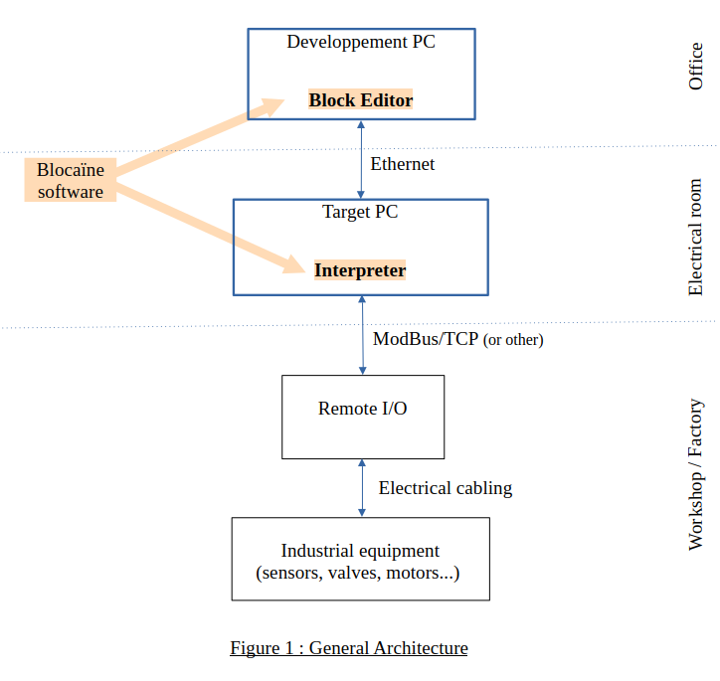
The Ethernet connection allows programs created with the Block Editor to be transferred to the Interpreter it also enables real-time visualization within the Block Editor variables of the programs currently being executed by the .

Features
- "Hot Swap”: A new version of a program can be loaded while the old version is currently running.
- Graphical programming in the form of linked functional blocks
- Each variable natively has a validity bit, which propagates from block to block.
- Dynamic typing of variables.
- The order in which the blocks are executed is managed automatically.
- The layout of the blocks is done automatically
- A web server allows to know the status of the Target
- OPC UA allows interface with IHM/SCADA
- ModBus/TCP allows interface with remote I/O
- Blocaine is free and open source software

Project progress
The Blocaïne project is at the functional prototype stage.
You can download it, for evaluation on "github.com",The installation procedure is described in the document "evaluation_en.pdf»
For more information, you can contact me by email: blocaine@barachet.com

Precautions for uses, responsibilities
The use of Blocaïne is at the user's own risk.

Principles

Everything is block
Each block consists of input(s), output(s), and the code that evaluates the outputs based on the inputs.
- For the basic blocks (called System blocks) it's a function written in Python that evaluates the outputs based on the inputs.
- For user-created blocks (called user blocks) it's a chain of system blocks or user blocks which allows us to evaluate the outputs based on the inputs
An executable program is simply a user block, a subroutine also take the form of a user block, the inputs/outputs of the blocks are themselves blocks (<inputs>,<output>), the <input> block has an output defined by an <output> block, while the block <output> has an output defined by a <input> block. In sort, everything is a block.

Hot Swap
The interpreter has two versions for each program (user block) : Shift A and Shift B. The new version of a block is always downloaded into the Shift that is not currently running. When a Hot Swap is initiated, the current values of the stored variables from the Shift that is currently running are transferred to the other Shift, which then takes over...

Method of execution
For each running user block, the interpreter periodically evaluates all the <output> blocks associated with a periodic task. the input of an <output> block is evaluated by the interpreter by first executing the previous block, inputs of this previous block is evaluated by first executing previous block and so on.
This approach eliminates the need to explicitly define the execution order of the blocks.

Typing of variables
Since Blocaïne is based on the Python language, the variables (input and output) used by the blocks are dynamically typed; their type can be anything, including complex structures, as long as it is a combination of types recognized by Python (string, integer, float, list, dictionary, etc.).

Validity bit
A validity bit associated with each block output is automatically evaluated at each execution, depending on the validity of the inputs and the possibility or impossibility of evaluating the output.

Default values
Each block entrance, whether it is a system or user block has a default value that can be modified at instantiation.

Block editor

Generalities
The Block editor allows :
- Creating and modifying programs in form user block containing functional blocks chains between them.
- Compiling, downloading and launching the current user block.
- Monitoring (Dynamic visualization) of I/O values of blocks.
- Overriding of I/O values of blocks.

Each block consists of:
- A header (Entête): containing the block name
- The entry(ies) (Entrées): located(s) left below the heading, containing the name of the entry.
- The exit(s) (Sortie): located(s) right under the heading, containing the name of the output.
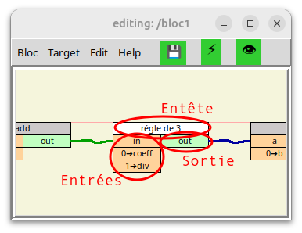
Blocks can be chained together by links, note that an output can only be linked to an input and an input can only be linked to a single output.
Each block corresponds to a file named: " block name.bloc ". System block files
are located in the /blocs/system directory, while the user block files are in /blocs/user.

Graphical interface
The graphical interface of the "Blocaïne" block editor consists of one or more windows, each containing the following
elements:
- A title bar : (Titre)
- A menu bar : (barre de menu):
- Three icons 💾, ⚡,👁️ : (icônes)
- A graphic area : (Zone graphique)
- A status bar: (Barre de status)

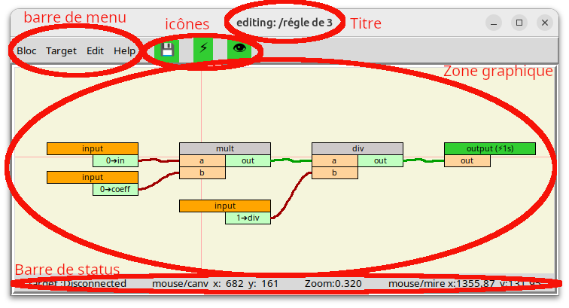
Graphical interface of the block editor

Title bar
At the top of each window is a title bar which contains:
- current mode: Editing or Monitoring
- the name of the user block currently being edited or debugged
Note that if the block was opened as a subblock, sub-subblock, etc., the path used to open it will appear before the block name. This is useful inMonitoring (debugging) mode to determine which instance of the block variables displayed in this window belong to.

Menu bar
The menu bar located in the top left corner below the title bar contains the following four menus:
- Bloc: is equivalent to the "File menu” in most softwares.
- Target: to manage the interface with the "Target" (so with the Interpreter).
- Edit: to manage the presentation.
- Help: documentation.

"Bloc” menu:
- Open: to open a file containing a block.
- Save [F3]: to save the block being edited in a file whose name corresponds to the name of the current block.
- Save as [F4]: to save the block being edited to a file whose name will be entered by the user.
- Update [F5]: to update all the external interfaces of the blocks used as a subroutine in the currently being edited user block.
- Change Properties: to modify the header fields associated with the user block currently being edited, such as "the author of the block", "keywords"...but also its "name".
- Open new windows: Opens a new Block Editor in a separate window, fully independent from the original Block Editor.
- Quit [Escape]: quits the current window, without saving the user block currently being edited.

"Target” menu:
- Disconnect from TargetOrConnect to Target:to connect to or disconnect from the "Target Machine"(so at theExecutor).
- Check <block_name>: to check if the block being edited is valid and compilable.
- Check& Transferrt <block_name>: checks that the block being edited is valid, compiles it, then transfers the result to the "Target" to the Shift that is not "running".
- Check, Transferrt & Execute <block_name>: checks that the block being edited is valid, compiles it, transfers the result in the "Target” to the Shift that is not "running", then the Interpreter launches its execution: in the event that the block is already running on the other Shift, a Hot Swap will be initiated. Otherwise a simple start (Run) will be initiated.
- Monitoring (Start/Stop) [Space]: allows switching between edit mode and debug mode.

"Edit” menu:
- Auto layout [F7]:This command performs an automatic layout.
- Status bar (show/hide):This command allows you to show or hide the "status bar".

"Help” menu:
- Versions: gives the version of the Block editor and the block structure.
- Mouse usage: gives instructions on how to use the mouse:
  - [Left click] to select, to use menu
  - [Left held down] to scroll within window, to move block, to link I/O
  - [Left double-click] to open user block
  - [Right button] to open the context menu
  - [wheel button] to monitor the target variables (on/off)
  - [wheel rotation] to zoom (in/out)
- Key use: gives instructions on use the keyboard:
  - [F1] Open the documentation for the block whose header is located under the cursor
  - [F3] to save current block
  - [F4] to save current block as
  - [F5] to update current block (update sub-block interfaces)
  - [F7] to layout current block
  - [Delete] Delete the block whose header is located under the cursor
  - [Space] to monitor the target variables (on/off)
  - [Escape] to close current Block Editor window
- General Documentation: opens this document.

Icons
These icons provide quick access to the most frequently used features:
- "💾": Save the current block.
- "⚡": Checks the consistency of the current block, converts him (compiles it) in a format understandable by the Interpreter, transfer the result to the “Target”, then start its execution:
  - If the current block is not already running in the “Target”, a stat order (run) is initiate.
  - If the current block is already running in the “Target”, a Hot Swap is initiate.
- "👁️": Switching between Editing and Monitoring modes.

Graphics Area
This area allows you to build a program (user block) by depositing blocks (system or user) and by linking them together.

Navigation
To navigate this area, you need to use a mouse :
- Rotating the dial: allows you to zoom in/out.
- Mouse movement with the left button held down:
  - On empty area: allows to move the visible area (scroll)
  - On I/O: allows you to create a link between an input and an output
  - On block header: allows to move the block
- Right-click: allows you to bring up the context menu.
- Double left click :
  - On user block header: opens the user block pointed in a new window.
  - On an I/O of a user block: opens the user block of the pointed I/O in a new window and positions the input or the output in the center of the graphics area
- Left click: allows selected a field in a menu.
- Click on the scroll wheel button: Enables/disables real-time visualization of variable values ​​located in the target (Monitoring On/Off)

Context menus

Default Menu
A Right-click on a virgin area, displays following context menu:
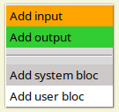
This menu allows you to add a block.

“bloc” Menu
A Right-click on the header of a block, displays the following context menu:

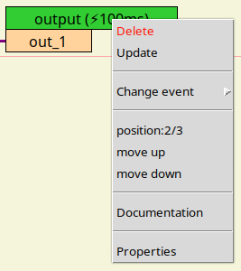

- Delete: allows the block to be deleted
- Update: updates the block's external interface, from that block's file.
- Change event : allows the block to be associated with a periodic task so that it can be executed. This field is only available for <output> blocks.
- Position: 2/3, move up,move down: allows you to change the order of inputs or outputs in the external interf of a user block currently being edited. This field is only available for <input> or <output> blocks.
- Documentation: opens the block help file in the default web browser. This field is only available if a help file named "block_{type of block}_{name of block}.html » is located in the “/Documentation” directory.
  - Type of block : maybe; “user” or “system”
  - name of block : corresponding to the name defined in the block header
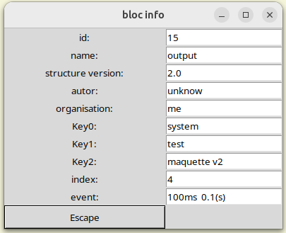
- Properties: displays the block properties like this.

“input” Menu
ARight-clickonaheader of a block, doneThe following context menu appears:
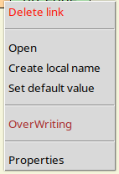

- Delete link : allowremoving the link with the previous block.This fieldnis availablethat ifthere is an li.e.n betweenthe entrance etthe output of another block.
- Open: allowopenira new window that edits the blockuserfrom the entrance, andposition L'entrancein the center of the graphics area.
- Ccreate locale name: allows namesealocalmentthe entry, this name is associated with the external interface of the instance.
- Clocal real estatehow: allowto add a commentlocal at the entrance, thiscommentis associated with the instance's external interface.
- Set default value: allows you to give a local default value to the input; this value is associated with the external interface of the instance.
- OverWriting : permand to override the value of the input.
- Properties: hasdisplay the properties ofthe entrance like this.
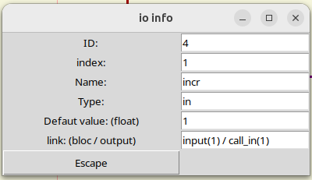

“output” Menu
ARight-clickonaexitall in one piece, madeThe following context menu appears:
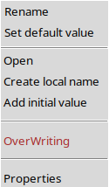
- Rename:allows you to rename the output name; this new name will appear in the block's external interface.This fieldnEastavailable only for the blockss<input>.
- Default set value:allows you to define the default value of the input linked to the block instance.This fieldnEastavailableonly for the blockss<input>.
- Open: allowopenira new window that edits the blockuserfrom the entrance, andposition Lexit in the center of the graphics area.This fieldnEastavailableonly for the blockss user.
- Ccreate locale name: allows namesealocalmentthe entry, this name is associated with the external interface of the instance.
- Clocal real estatehow: allowto add a commentlocal at the entrance, thiscommentis associated with the instance's external interface.
- Add initialvalue: allows you to assign a valueinitial to a "memorized" output.This fieldnEastavailablethat for all blocks whose output is "memorized" from one cycle to the next, e.g. <memory>, <previous>, <edge>.
- OverWriting : permand to overload the value of theexit.
- Properties: hasdisplay the properties ofelexit like this.
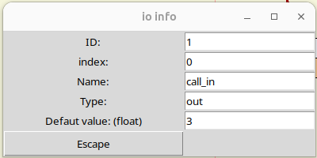

Insert a block
To insert a block, you need to right-click on a virgin area,in order to display the following context menu:

You then need to choose the type of block you want:
- Add input: to create a new entry in the user block currently being edited.
- Add output: to create a new output in the user block currently being edited.
- Add system bloc: for insert a block that is part of the standard library.
- Add user bloc: for insert a previously created user block.

Delete a block
To delete a block, you can right-click on the header of the block to be deleted, in order to display the following context menu:
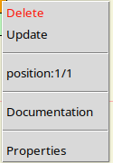

Then select Delete.
You can also position the cursor on the header of the block to be deleted, then press the "Delete" key.

Create a link
To link the output of one block to the input of another block, click and hold the left mouse button on the output of the first block, then drag (left button still pressed) until the input of the second block, and then release the left mouse button. Links can be created from either input to output or output to input, but an input can only have one source (i.e., originate from only one output).

Delete a link
There are two ways to remove a link:
Either right-click on the link,in order to display the following context menu:
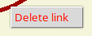

then select Delete link
Either right-click on the input located at the end of the link, in order to display the following context menu:
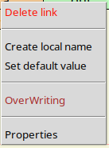

Then select Delete link

Status bar
The status bar displays :
- The state of there connection with the Target.
- The position of the mouse in relation to the graphics area (canvas)).
- The zoom coefficient.
- The position of the mouse relative to the crosshair.

input(s)/output(s)
The interface of a user block is made up of input(s) and output(s); the latter are optional but essential for the interconnection with the other blocks.
- An inputs is collected using a system blocks named <input>
- An output is delivered using a system blocks named <output>

<input> block
Here is the external interface of the <input> system block.
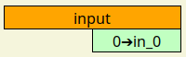

Its function is to define an input for a user block. The <input> block has no input, but possesses an output named "in_0", that is the variable (of any type) that will be entered into the user block. Its default value is 0 (int), and it can be adjusted for each instance of an <input> block. This output can be renamed; the new name will appear in the user block's external interface as an input.

block <output>
Here is the external interface of the<output> system block.
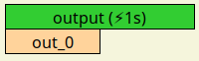

Its function is to define an input for a user block. The <input> block has no input, but possesses an output named "in_0", that is the variable (of any type) that will be entered into the user block. Its default value is 0 (int), and it can be adjusted for each instance of an <input> block. This output can be renamed; the new name will appear in the user block's external interface as an input.

External interface of a user block
Here is a user block called the <régle de 3> Which contains three <input> blocks and one <output> block.
- The output of the first <input> block has been named to "in"
- The output of the second <input> block has been named to "coeff"
- The output of the third block <input> has been named to"div"
- The input for the <output> block has been named to "out".
Figure: <régle de 3> user block
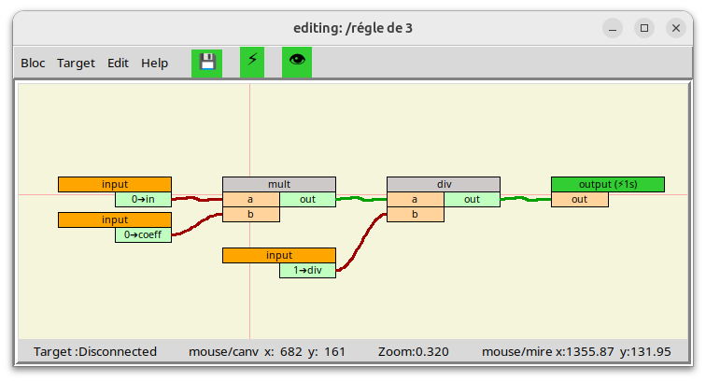

Here is the external interface of the <régle de 3> block, here a user block named <block1> refers to the <rule of 3> user block, the 3 inputs and the output correspond to the <input>/<output> defined in the <rule of 3> block and are indeed present in its external interface.
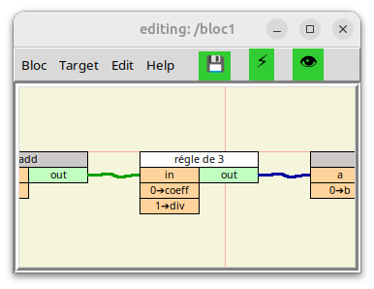

Figure; external interface of the blockuser<rule of 3>
The order in which inputs and outputs of appear in the external interface of a user block can be modified as follows:
- Open the user block whose input and/or output order, by double-clicking on the header of the block to be modified, if it is present in the graphics area, or by using the menu bar (bloc/open) or (block/open new window then bloc/open).
- Right-click on the header of the <input> or <output> block, depending on whether you want to change the order of the inputs or outputs. This will bring up the following context menu:
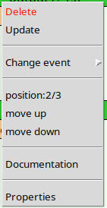
- Position: 2/3: indicates the position in the external interface of the input or output you have selected. You can select move up or move down to shift it one a position up or down.

Editing/Monitoring mode
Switching from "editing" mode to "monitoring” mode, and vice versa, is carried out either by clicking on the "eye" icon (👁️), either by pressing the well button of the mouse, of course the block being on screen must be in progress to be able to switch to "monitoring" mode.

Editing Mode
This mode is dedicated to creating and modifying user blocks.
Here is an example of a user block which calculates the average of 2 numbers in “editing” mode, please note that window title shows the current mode:
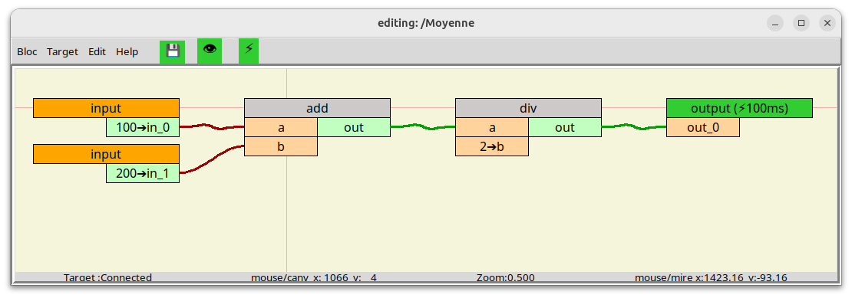
Figure 2:block in edit mode

Monitoring Mode:
This mode is dedicated to debugging; it allows real-time visualization of the values ​​of variables within a user block or a user sub-block...
The validity of each variable is represented by the background color:
- Green = valid
- Red = invalid
- Yellow = forced and valid
- Black = Forced and invalid
Here is an example of <Moyenne> block in “Monitoring” mode (dynamic visualization), please note that window title shows the current mode:
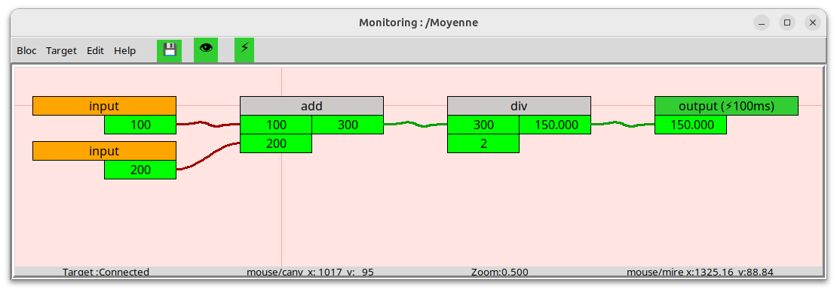
Figure3: blockin dynamic visualization mode

Validity bit
The validity bits can be read or amended using the system blocks following:
- <valideRead>: allows you to read the validity bit, this allows for example select a fallback value in the case of variable is " invalid "
- <valideWrite>: allows writing the validity bit, authorizing the user to define its own equation of validity.

Interpreter

Generalities
Rappel:L'executor Eastinstalle on a PCcalled" Machine target ",he executes THEs programs (blocksuser)who pilotsnt L'equipmentindustrial using thebetweenes/outputsdeported.
Ccertain ordersrelated to the blocksuseralready presentInL'executor,suchTHEthat :THEstarte,L'stop,L'initialization,THEswap,the removal,can beaccomplished byL'executor throughits integrated web server will chapter#7.5.
The operationsofmodifiedcation dAblockuser or visualisation in real timethe valuesdthe variables ofblocksuserrunning,are not availablethat from L'Block editors.

Execution Methode
ForthatAchaining ofblocks contained inAblock user beexecutable, it is imperative thatcThe chaining ends withan <output> blockand that thislasteitherpartnerat an event(like theperiodic event at 100msFor example).L'Executor evaluatesperiodicallyall the blocks<output>of the blockuser,thus triggering the evaluation ofuprevious blockwhich requires evaluation of the previous block and so on. Thisapproach eliminatesthe need fordefinitionir explicitlythe order of execution.
Un blockusercan contain multiple <output> blocks, each <output> being able to be associated withAeventperiodicdifferent. It is therefore possible to include in the same blocksuserchainsisof blocks that will be executedwithdifferent periodicities.If heexistslinksbetween blockchains of different periodicities, on each inter-chain link you will need to insertAblockssystem<previous>,so that the chain that needs to be executed slowly is notexecuted at the fastest chain period.

Hot Swap
For on-the-fly loading to be possible, the'Executorhasfor eachblockuser (program) oftwoversionsShift AAndShift B.There new versionin one piece user Eastalwaysdownloaded into theShiftwhich is not currently running,when a "hot swap" is initiated,the valuesscurrents variablesofShiftprocesses currently in progress are transferred to theotherShift,who then takes over.

Validity bit
Generally speaking, as long as a block has not been evaluated, its outputs are "iinvalids»
The validity associated with each output is evaluated automaticallyduringthat the block isexecutedyouSi ae inputs necessary for evaluating the output are "iinvalid"or if the exit of theblock cannot be evaluated because of a type conflictor otherthe exitwill be"iinvalid"OtherwiseShewill be"valide"

HMI/SCADA interface
The Interpreter includes an OPC UA server; dedicated system blocks are available to let you expose the variables you want.

Remote i/o
Remote input/output is managed by dedicated system blocks.
Currently, only the Modbus/TCP protocol is supported:
- modbus_conn: TCP connection with the remote input/output module
- modbus_read: reading from a ModBus slave
- modbus_write: writing to a ModBus slave

Web Server

Generalities
A HTTP server is integrated into the Interpreter, it allows the user through a simple web browser to view the status of the Target:
- View the available tasks and the number of <output> associated
- View overall and per task CPU load
- View the list of blocks available in the Target and the status of the Shifts (A & B) (Pending, Ready, Running)
- Visualize the state and value of the <output> of all blocks for the Shifts (A & B)
- Visualized the current Ethernet connections managed by the Interpreter
It also allows you to place simple commands such as:
- Stop the execution of a user block (order :Stop)
- Start the execution of a user block (command: Run)
- Initialize a user block (command: Initialize)
- Delete a user block (command: Delete)
- Swap the Shift A and Shift B
  - When none Shift is "Running" (command: ClodSwap)
  - When a Shift is "Running" (command: HotSwap)
- Launch command dedicated to debugginghttp://127.0.0.1:8080/
  - Printing all blocs known to the Interpreter (command: print list_compiled)
  - Printing all tasks known to the Interpreter (command: print list_threads)

Web server address
By default, the address is: http://127.0.0.1:8080/
As in the evaluation version (downloadable from Github), since the target PC and the development PC are on the same PC, the web server's IP address is 127.0.0.1 (note that port 80, the default port for the HTTP protocol, is not used); we use port 8080 so that the Executor can be launched without needing a sudo command.

Example of page "Bloc”

Example of page “Output”

Example of page "Overwriting"

Example of page "Task & load"

Example of page "Connection”

Create a system block
Foradd ablockhas the standard library,it's necessary :
- Create the external interface (graphical interface)of the new block.
- Codezthe associated "Python" functionto the new blockand aadd the block name to the list of blocksthe standard library.
NNote that it will be necessary to restart theExecutorAndL'Block editorto take into accountcthe new blocksystem.

Ccreate the external interface
OpenL'Block editor.
In the menu bar, click on "Block" then "Change Properties" to open the following "block info" window:
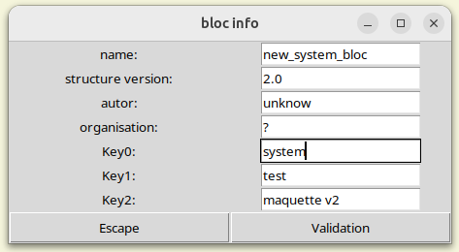
Figure: info block
Enter the name of the new blocksystemIn the "name:" field, enter "system" in the "Key0:" field. Confirm your entry by clicking "Validate".
In the graphics area,addblockssystem<input> and/Or<output> depending on the number of inputs and outputs needed, renamezthese inputs/outputsAndtheirsassign a default value, thenPress the [F3] key to save.
To verify that the interface has been created correctly, open a new window and then insert a blocksystemThe newly added block should appear in the list; select it, and verify that the external interface matches what you want.

Create the Python code
The functions associated with the blocksystemare in the fileer/Target/exec.py, byFor example, here is the Python functionassociated withblocksystem<and>:
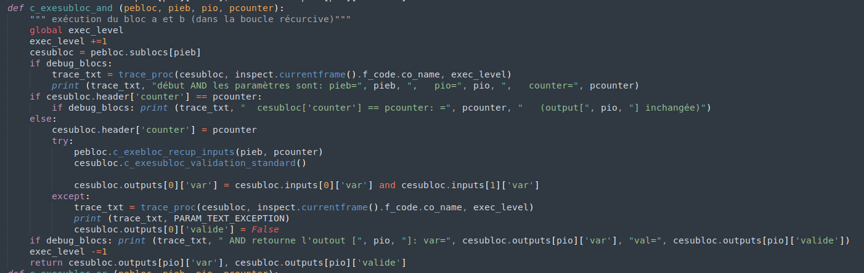
Figure: “c_exesubloc_and” function
If we disregard the elements related to debugging, itstaythat this:
1def c_exesubloc_and (pebloc, pieb, pio, pcounter):
2 cesubloc = pebloc.sublocs[pieb]
3 if cesubloc.header['counter'] == pcounter:
4 pass
5 else:
6 cesubloc.header['counter'] = pcounter
7 try:
8 pebloc.c_exebloc_recup_inputs(pieb, pcounter)
9 cesubloc.c_exesubloc_validation_standard()
10 cesubloc.outputs[0]['var'] = cesubloc.inputs[0]['var'] and cesubloc.inputs[1]['var']
11 except:
12 cesubloc.outputs[0]['valid'] = False
13 return cesubloc.outputs[pio]

Explanation of the code:
LLine 1: The name oftherefunction is "c_exsubloc_" followed bysystem block name.The parameters are:
- pebloc: is the "executable" structure of the blockuserrunning.
- pieb: is the index of the blocksystem to execute
- pio: is the index of the output whose value needs to be returned
Line 2: allows you to point to the block to be executed.
Line 3: checks if the block has already been executed
Line 6: marks the block as already executed
Line 8:recoverall the block entries
Line 9: affects all bitssvalidation of block outputsbased on its inputs
Line 10: assigns the output based on the inputs (logical AND)
Line 12: sets the validity bit to "invalid" in case the block calculation did not complete correctly
Line 13: returns the outputrequested (pio index output)

In mostIn some cases, your new function will be identical to that of the blocksystem<and>, except:
- line 1: since the function name will be different.
- line 10: since you will assign the outputs according to the inputs as needed.

Still in the file: /Target/exec.py, you need to add the association between the name of your new blocksystemand the newly created Python function, thatx-ci takes place intherefunction“recup_procedure”.
Note thatthis function is usedbyL'Block editor when a blockuserEast compiled:
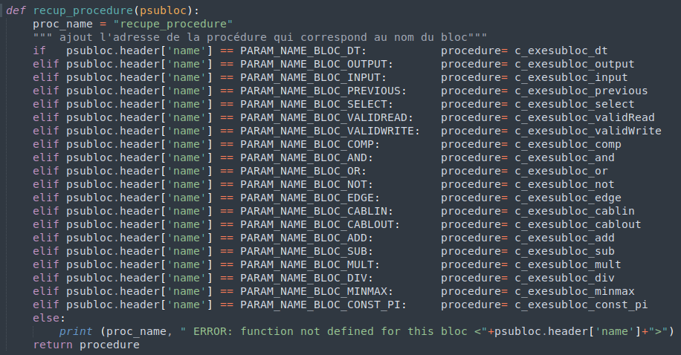
Figure: function "recup_procedure"

PTo do this, you will need to add a line before the "else" and create a new parameter whose name will consist of:
"PARAM_NAME_BLOCK_" followed by the name of your new blocksystemin capital letters.

IYou will also need to modify the file /Target/PARAM_NAME_BLOC.py,in add to ita line to define the constant "PARARM_NAME_BLOCK_yourblock,The string of characters to the right of the "=" sign corresponds to the filename of your new blocksystem.
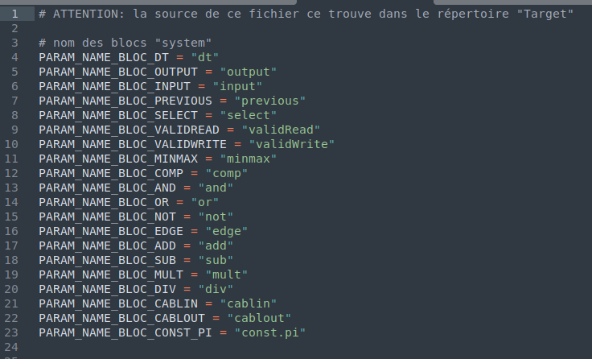
Figure: PARAM_NAME_BLOCK.py file

